PROJECT REPORT ON **WEB TECHNOLOGY**

TO CREATE A WEB-BASED CALCULATOR

**CAPITAL COLLEGE AND RESEARCH CENTER**

Koteshwor, Kathmandu, Tel: 5100423, 5100456

Email: [info@ccrc.edu.np](mailto:info@ccrc.edu.np), Web: www.ccrc.edu.np



**DEPARTMENT OF COMPUTER SCIENCE**

**Submitted By:**

Ravi Mandal

Class: XII, Sec: P6

Stream: Science

Symbol No.: ___________

**Submitted To:**

_________________

Mr. Ranjan Dulal

HOD

Computer Science Department

**For the partial requirement for fulfilment of the degree of**

**National Examinations Board (NEB) Examination**

**20th Falgun, 2080 B.S.**

# LETTER OF APPROVAL

This is to certify that this project report prepared by **Mr. Ravi Mandal** entitled “*Project Report on Web Technology to create a web-based calculator*” in partial fulfillment of the requirements for the degree of National Examinations Board (NEB) examination, has been well studied. It is satisfactory in scope and quality as in project report for the required degree.

**Evaluation Committee**

………….………………………….... …………..…………………………

**Program Coordinator HOD**

Mr. Rajendra Pokhrel Mr. Ranjan Dulal

Administrative Department (Science) Department of Computer Science

Capital College and Research Center Capital College and Research Center

Koteshwor, Kathmandu Koteshwor, Kathmandu

…………..…………………………

**External Examiner**

Mr. __________________________

N.E.B.

Kathmandu, Nepal

# LETTER OF DECLARATION

I, **Ravi Mandal,** student of Capital College and Research Center (CCRC), hereby declare that the project report entitled **"Project Report on Web Technology to create a** **web-based calculator "** submitted by me to the College and National Examinations Board (N.E.B.) in partial fulfillment of the requirement for the award of N.E.B. examination is a record of project work carried by me under the guidance of (Program Coordinator) Mr. Rajendra Pokhrel, (HOD) Mr. Ranjan Dulal, and (Lecturers) Mr. Abhishek Dhungel, Mr. Sajan Kharel and Mr. Bivash Kumar Shah Sir.

I further declare that this report is the original and self-done work and is not subject to anyone else's work, apart from references.

Name: Ravi Mandal

Class: XII, Sec: P6

Stream: Science

Symbol No.: _____________________

Capital College and Research Center

Koteshwor, Kathmandu

# ACKNOWLEDGEMENT

This is my project report on Web Technology. I would like to express my deepest gratitude to Mr. Rajendra Pokhrel Sir, the Program Coordinator of Science Stream & consider myself to be very fortunate to get an opportunity to study, work and pursue my research under the guidance of my respected teachers (HOD) Mr. Ranjan Dulal, (Lecturers) Mr. Abhishek Dhungel, Mr. Bivash Kumar Shah, Mr. Sajan Kharel Sir and (Computer Lab Teachers) Mr. Umesh Joshi as well as Mr. Sagar Shreshta Sir who guided me throughout the report and helped me to find rooms for improvement which made the report a lot finer. Hence, first and foremost, I express my deepest sense of gratefulness towards them.

I wish to express my sincere gratitude to the principal of Capital College and Research Center, Mr. Hari C. Lamichhane Sir and all the teachers at CCRC, who gave me their utmost platform and cooperation to succeed in completing this learning process.

The aim of this report is to illustrate the project’s subject matter, background knowledge of the subject, development and progress which will be beneficial for individuals who are interested in working on the C programming Concept/Web Technology Concept.

Although this report has been prepared with utmost care and deep routed interest, even then I accept respondent and imperfection.

Thank You.

Name: Ravi Mandal

Class: XII, Sec: P6

Stream: Science

Symbol No.: _____________________

Capital College and Research Center

Koteshwor, Kathmandu

**TABLE OF CONTENTS**

LETTER OF APPROVAL 2

LETTER OF DECLARATION 3

ACKNOWLEDGEMENT 4

HOW WEB TECHNOLOGY ARCHITECTURE WORKS? 7

SYSTEM TOOLS AND SOFTWARE REQUIREMENTS 9

Tools and Technologies Used 9

System Requirements 9

ER DIAGRAM 10

USE CASE DIAGRAM 11

DEVELOPMENT ENGAGEMENT 12

Q. 1. Design a website for web based calculation 12

connection.php 12

login.php 13

signup.php 17

login-signup-style.css 23

index.html 26

index2.html 27

index-style.css 28

simple-cal.html 32

factorial.html 37

about.html 40

about2.html 44

about-style.css 49

OUTPUT 57

FINDING 59

FUTURE SCOPE AND FUTURE ENHANCEMENT 59

CONCLUSION 60

REFERENCES 61

## 

**INTRODUCTION TO WEB TECHNOLOGY**

Web technologies refers to the way computers/devices communicate with each other using markup languages. It involves communication across the web, and creates, delivers, or manages web content using hypertext markup language (HTML). A web page is a web document which is written in HTML. It is said to have brought the world into a small village where people and devices can communicate to each other seamlessly. WWW has allowed for the access of information that would have been impossible to find or may have been difficult to find without the www.

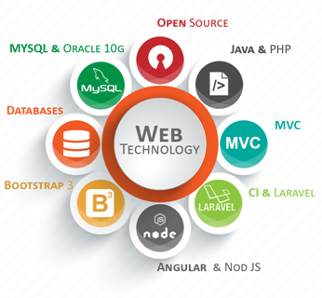

**Source**: <https://softwebdevelopment.com/wp-content/uploads/2019/03/pp-web-technology.png>

Web technology encompasses the tools and frameworks that enable the creation and functioning of websites and web applications. At its core are programming languages like Java and PHP, which developers use to write the code that powers these digital platforms. Open-source technologies, such as Java and PHP, offer flexibility and accessibility, allowing developers to collaborate and innovate freely. Databases like MySQL play a crucial role in storing and managing data for web applications, ensuring efficient retrieval and manipulation of information.

**FEATURES OF WEB TECHNOLOGY**

* Client-side scripting languages like JavaScript.
* Markup languages like HTML.
* Stylesheet languages like CSS.
* Server-side scripting languages like PHP, Ruby, Python, etc.
* Database technologies like MySQL.

# HOW WEB TECHNOLOGY ARCHITECTURE WORKS?

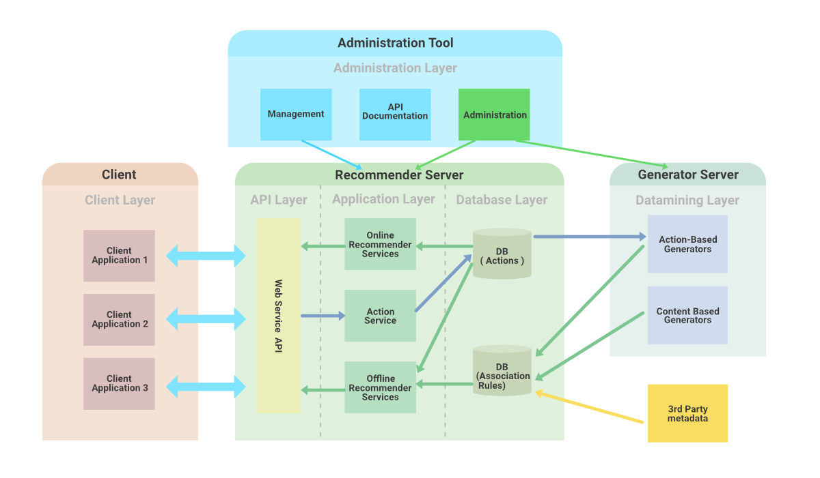

**Source**:https:// www.geeksforgeeks.org

While working on the web application, a web developer decides the functions of the code on the server and the functions of the code on the browser. They also define how these two will function in relation to each other. Server-side code can be written using the languages Python, JavaScript, C#, PHP, Ruby on Rails, etc. The server-side code is mainly responsible for creating the page which the user has requested. It also stores different types of data such as user profiles, tweets, pages, etc. Server-side code can not be seen by the end-user.

**OBJECTIVES**

* To comprehend the basics of the internet and web terminologies.
* To introduce scripting language concepts for developing client-side applications.
* To practice server-side programming features – PHP, JSP.

## 

# SYSTEM TOOLS AND SOFTWARE REQUIREMENTS

## 

## Tools and Technologies Used

**IDE :-** Visual Studio Code, XAMPP

**Operating System** :- Windows 11

## System Requirements

**Processor :-** Any modern processor

**RAM :-** 4GB or higher

**Storage :-** A few gigabytes of free storage

## 

## 

## 

## 

## 

## 

## 

## 

## 

## 

## 

# ER DIAGRAM

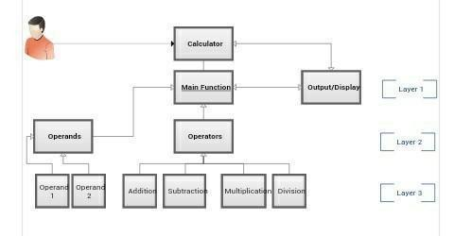

**Source** : <https://brainly.in>

An ER diagram for a web-based calculator shows how users, calculators, and individual calculations are connected. It's like a map that helps developers build the calculator and users understand how it works. By seeing this diagram, everyone involved can easily grasp how information flows within the system and how different parts fit together, making the development process smoother and communication clearer.

Web-based calculators have become indispensable tools for a myriad of tasks, ranging from simple arithmetic calculations to complex mathematical analyses. Understanding the underlying structure of such systems is crucial for developers and users alike. An Entity-Relationship (ER) diagram serves as a blueprint, offering a visual representation of the essential entities and their relationships within the system.

The ER diagram for a simple web-based calculator provides insights into how users interact with the calculator application and how data flows within the system. At its core, the diagram outlines the key entities involved, such as users, calculators, and individual calculations, and elucidates the relationships among them.

# USE CASE DIAGRAM

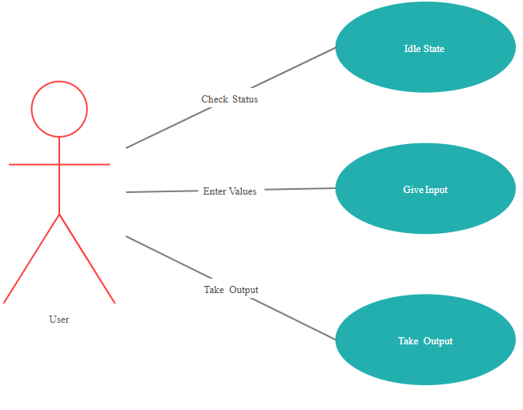

**Source :** <https://creately.com/diagram/example/hd6vhslu1/calculator-use-case-system>

A use case diagram offers a high-level view of how users interact with a system, capturing various scenarios or "use cases" that depict user actions and system responses. In the context of a calculator application, the use case diagram illustrates the primary functionalities users can perform and the system's responses to those actions.

When a user engages with the calculator, they transition from an "Idle Status" to an active state, triggering actions such as providing input. The system then processes this input and transitions to a "Check Status" phase, where it evaluates the input and generates the corresponding output. Subsequently, the system may return to an "Idle Status," awaiting further user interaction.

In essence, this use case diagram offers a simplified yet comprehensive overview of the calculator application's functionality, mapping out the sequence of interactions between users and the system. It serves as a valuable tool for developers, designers, and stakeholders, facilitating a clear understanding of user requirements and system behavior throughout the development lifecycle.

# DEVELOPMENT ENGAGEMENT

## Q. 1. Design a website for web based calculation

### connection.php

<?php

$servername = "localhost";

$fullname = "root";

$password = "";

$dbname = "loginsystem";

$con = new mysqli($servername, $fullname, $password);

if (!$con) {

die("Connection failed!!");

} else {

// echo("Connection Done :)");

}

$sql = "CREATE DATABASE IF NOT EXISTS $dbname";

$query = mysqli_query($con, $sql);

if (!$query) {

die("<br>Couldn't created DATABASE!!") . mysqli_connect_error();

} else {

// echo("<br>DATABASE CREATED SUCCESSFULLY :)");

}

$con->select_db("$dbname");

$sql = "CREATE TABLE IF NOT EXISTS users (

id int(30) PRIMARY KEY NOT NULL AUTO_INCREMENT,

fullname VARCHAR(50) NOT NULL,

email VARCHAR(50) NOT NULL,

password VARCHAR(50) NOT NULL

)";

$query = mysqli_query($con, $sql);

if (!$query) {

die("<br>TABLE COULDN'T CREATED!!") . mysqli_connect_error();

} else {

// echo("<br>TABLE CREATED SUCCESSFULLY :)");

}

?>

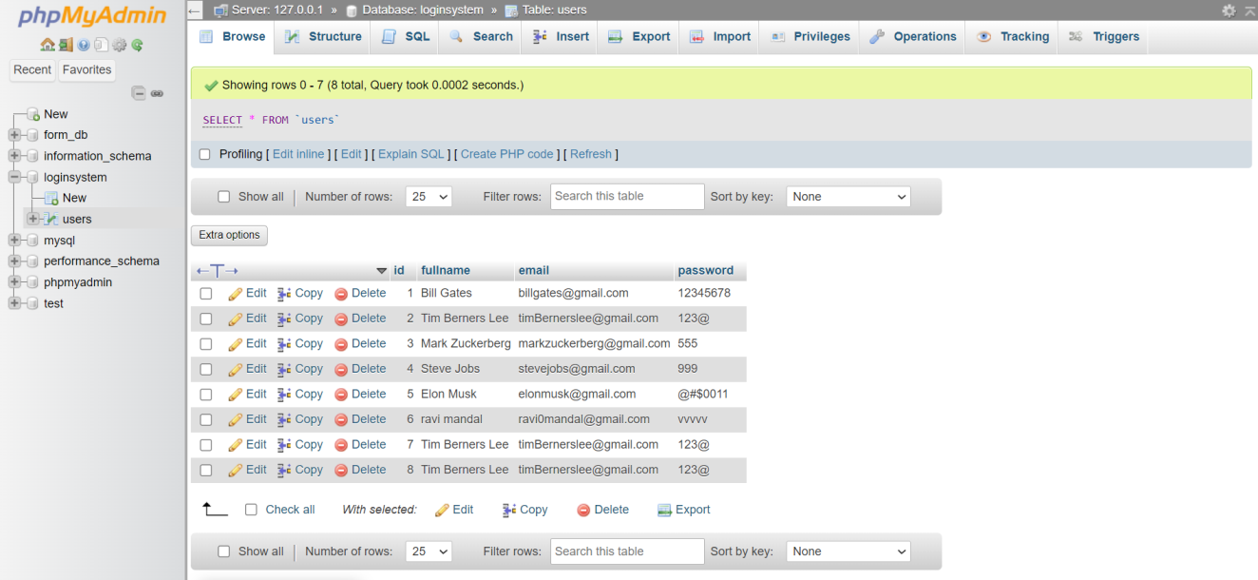

### login.php

<?php

session_start();

require_once "connection.php";

if ($_SERVER["REQUEST_METHOD"] == "POST") {

$email = $_POST["email"];

$password = $_POST["password"];

$sql = "SELECT id FROM users WHERE email = ? AND password = ?";

if ($stmt = $con->prepare($sql)) {

$stmt->bind_param("ss", $email, $password);

if ($stmt->execute()) {

$stmt->store_result();

if ($stmt->num_rows == 1) {

$_SESSION["email"] = $email;

$_SESSION["loggedin"] = true;

header("location: Dashboard/index2.html");

} else {

$login_err = 'Incorrect Email or Password, Please try again';

}

} else {

echo "Oops! Something went wrong. Please try again later.";

}

$stmt->close();

}

$con->close();

}

?>

<!DOCTYPE html>

<html lang="en">

<head>

<meta charset="UTF-8">

<meta name="viewport" content="width=device-width, initial-scale=1.0">

<title>Login</title>

<link rel="stylesheet" href="login-signup-style.css">

</head>

<body>

<div class="back">

<div class="back-btn">

<h2><a href="Dashboard/index.html">BACK TO HOME</a></h2>

</div>

</div>

<form action="<?php echo htmlspecialchars($_SERVER["PHP_SELF"]); ?>" method="post" onsubmit="return validateForm()">

<h2>Login</h2>

<label for="email">Email:</label><br>

<input type="email" id="email" name="email" onblur="validateEmail()"><br>

<span id="emailError" class="error">Please enter a valid email ending with '@gmail.com'.</span><br>

<label for="password">Password:</label><br>

<input type="password" id="password" name="password" onblur="validatePassword()"><br>

<span id="passwordError" class="error">Please enter a valid password.</span><br>

<?php if (isset($login_err))

echo "<p>$login_err</p>"; ?>

<input type="submit" value="Login">

<div class="footer">

<p>Don't have an account? <a href="signup.php">SIGNUP NOW</a></p>

</div>

</form>

</body>

</html>

<script>

function validateForm() {

var isValid = true;

if (!validateEmail()) {

isValid = false;

}

if (!validatePassword()) {

isValid = false;

}

return isValid;

}

function validateEmail() {

var emailInput = document.getElementById('email');

var emailError = document.getElementById('emailError');

if (emailInput.value.trim() === '') {

emailError.style.display = 'inline';

return false;

} else if (!emailInput.value.trim().endsWith('@gmail.com')) {

emailError.innerText = 'Please enter a valid email ending with \'@gmail.com\'.';

emailError.style.display = 'inline';

return false;

} else {

emailError.style.display = 'none';

return true;

}

}

function validatePassword() {

var passwordInput = document.getElementById('password');

var passwordError = document.getElementById('passwordError');

if (passwordInput.value.trim() === '') {

passwordError.style.display = 'inline';

return false;

} else {

passwordError.style.display = 'none';

return true;

}

}

</script>

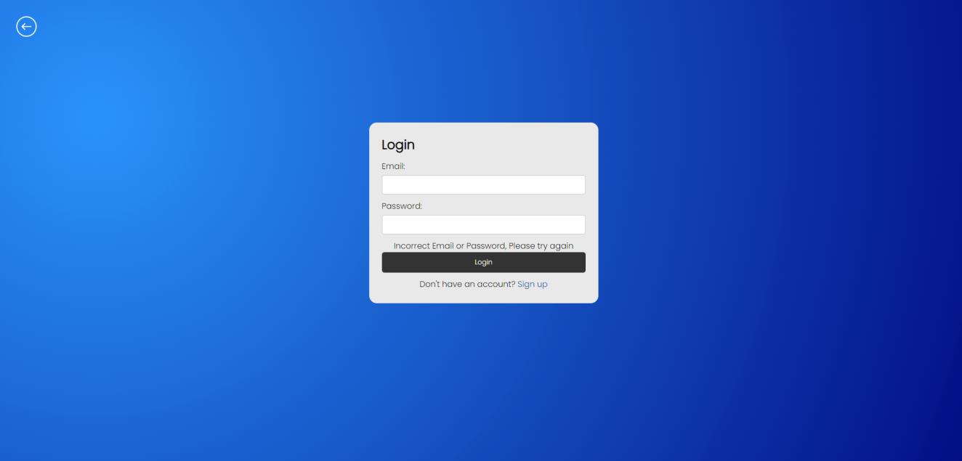

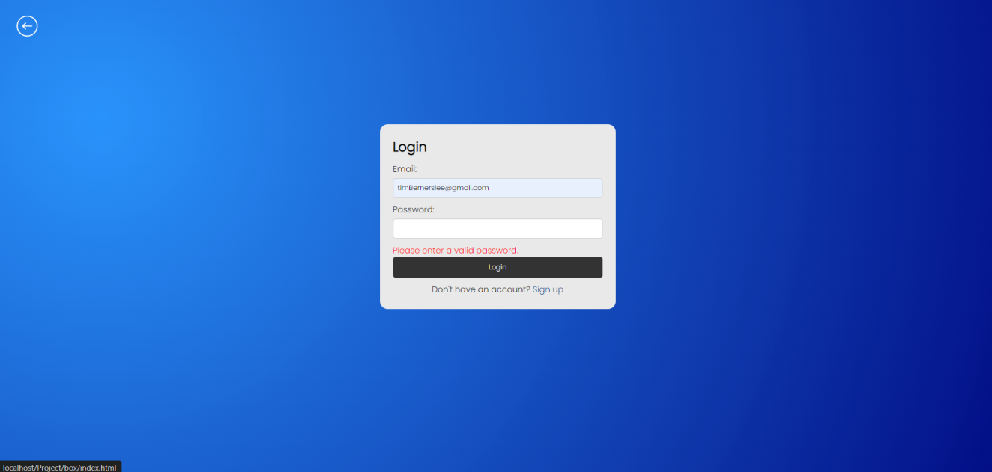

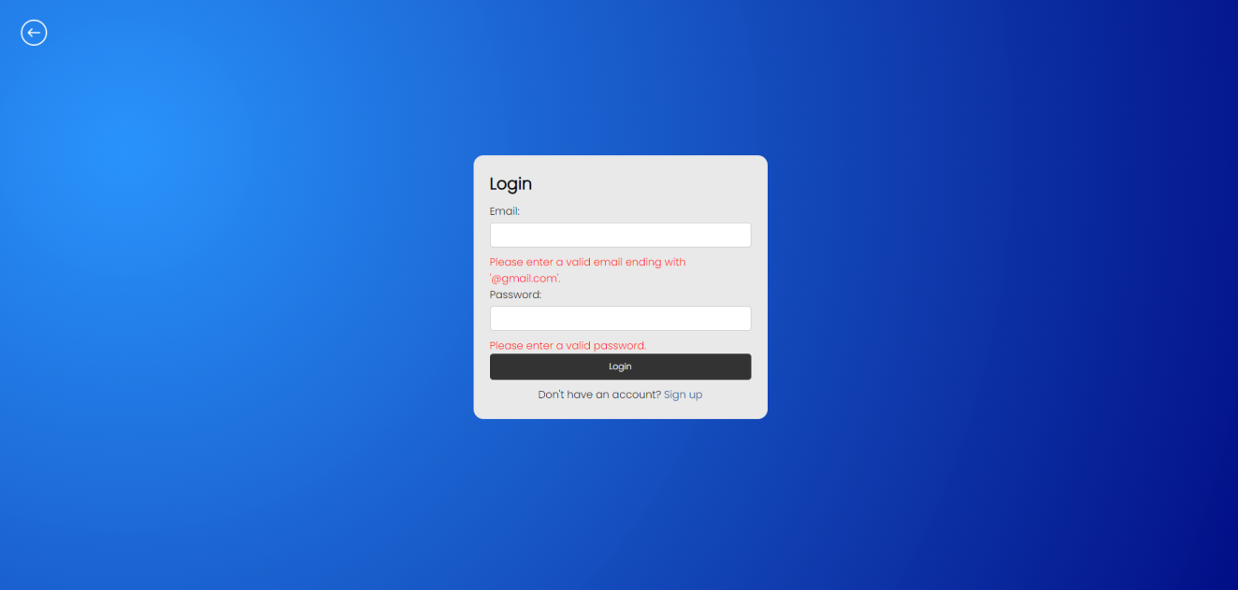

### signup.php

<?php

require('connection.php');

if ($_SERVER["REQUEST_METHOD"] == "POST") {

$fullName = $_POST['fullName'] ?? '';

$email = $_POST['email'] ?? '';

$password = $_POST['password'] ?? '';

if (!empty($fullName) && !empty($email) && !empty($password)) {

$sql = "INSERT INTO users (fullName, email, password) VALUES ('$fullName', '$email', '$password')";

if ($con->query($sql) === TRUE) {

echo "REGISTERED SUCCESSFULLY";

} else {

echo "Error: " . $sql . "<br>" . $con->error;

}

$con->close();

} else {

echo "All fields are required";

}

}

?>

<!DOCTYPE html>

<html lang="en">

<head>

<meta charset="UTF-8">

<meta name="viewport" content="width=device-width, initial-scale=1.0">

<title>Register</title>

<link rel="stylesheet" href="login-signup-style.css">

</head>

<body>

<div class="back">

<div class="back-btn">

<h2><a href="Dashboard/index.html">BACK TO HOME</a></h2>

</div>

</div>

<form id="registrationForm" onsubmit="return validateForm()" method="post">

<h2>REGISTER</h2>

<label for="fullName">Full Name:</label><br>

<input type="text" id="fullName" name="fullName" onblur="validateFullName()"><br>

<span id="fullNameError" class="error">Please enter a valid full name.</span><br>

<label for="email">Email:</label><br>

<input type="email" id="email" name="email" onblur="validateEmail()"><br>

<span id="emailError" class="error">Please enter a valid email ending with '@gmail.com'.</span><br>

<label for="password">Password:</label><br>

<input type="password" id="password" name="password" onblur="validatePassword()"><br>

<span id="passwordError" class="error">Please enter a valid password.</span><br>

<label for="confirmPassword">Confirm Password:</label><br>

<input type="password" id="confirmPassword" name="confirmPassword" onblur="validateConfirmPassword()"><br>

<span id="confirmPasswordError" class="error">Passwords do not match.</span><br>

<input type="submit" value="Submit">

<div class="footer">

<p>Already have an account? <a href="login.php">LOGIN NOW</a></p>

</div>

</form>

<script>

function validateForm() {

var isValid = true;

if (!validateFullName()) {

isValid = false;

}

if (!validateEmail()) {

isValid = false;

}

if (!validatePassword()) {

isValid = false;

}

if (!validateConfirmPassword()) {

isValid = false;

}

return isValid;

}

function validateFullName() {

var fullNameInput = document.getElementById('fullName');

var fullNameError = document.getElementById('fullNameError');

if (fullNameInput.value.trim() === '') {

fullNameError.style.display = 'inline';

return false;

} else if (!/^[a-zA-Z\s]+$/.test(fullNameInput.value.trim())) {

fullNameError.innerText = 'Please enter only alphabets.';

fullNameError.style.display = 'inline';

return false;

} else {

fullNameError.style.display = 'none';

return true;

}

}

function validateEmail() {

var emailInput = document.getElementById('email');

var emailError = document.getElementById('emailError');

if (emailInput.value.trim() === '') {

emailError.style.display = 'inline';

return false;

} else if (!emailInput.value.trim().endsWith('@gmail.com')) {

emailError.innerText = 'Please enter a valid email ending with \'@gmail.com\'.';

emailError.style.display = 'inline';

return false;

} else {

emailError.style.display = 'none';

return true;

}

}

function validatePassword() {

var passwordInput = document.getElementById('password');

var passwordError = document.getElementById('passwordError');

if (passwordInput.value.trim() === '') {

passwordError.style.display = 'inline';

return false;

} else {

passwordError.style.display = 'none';

return true;

}

}

function validateConfirmPassword() {

var passwordInput = document.getElementById('password');

var confirmPasswordInput = document.getElementById('confirmPassword');

var confirmPasswordError = document.getElementById('confirmPasswordError');

if (confirmPasswordInput.value.trim() === '') {

confirmPasswordError.style.display = 'inline';

return false;

} else if (passwordInput.value !== confirmPasswordInput.value) {

confirmPasswordError.style.display = 'inline';

return false;

} else {

confirmPasswordError.style.display = 'none';

return true;

}

}

</script>

</body>

</html>

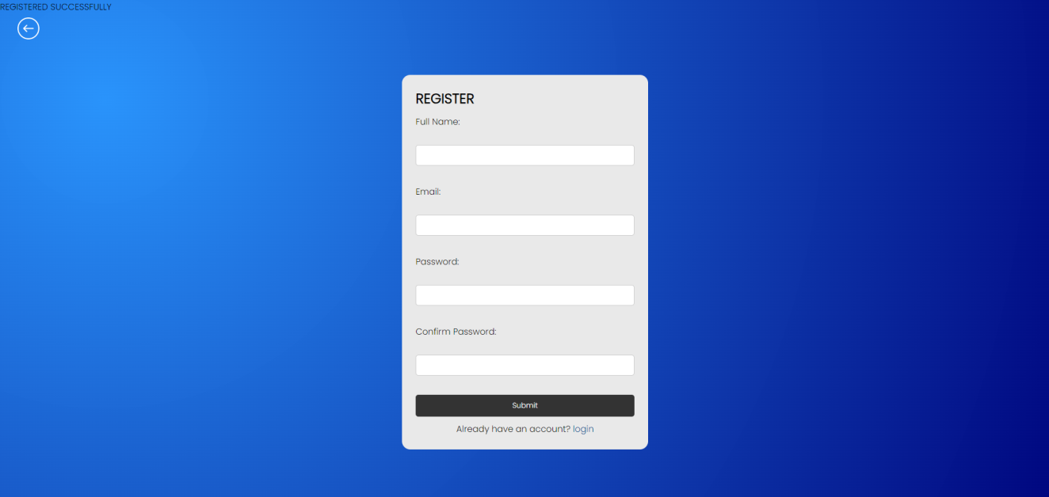

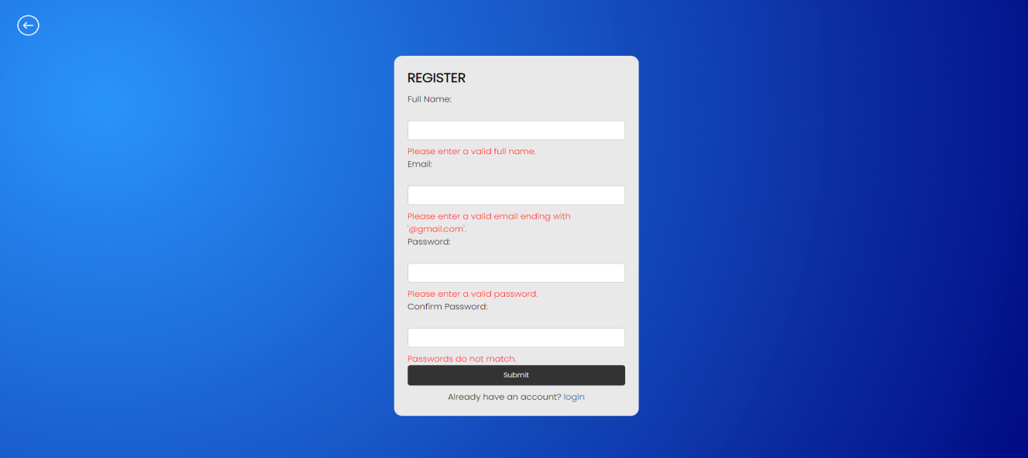

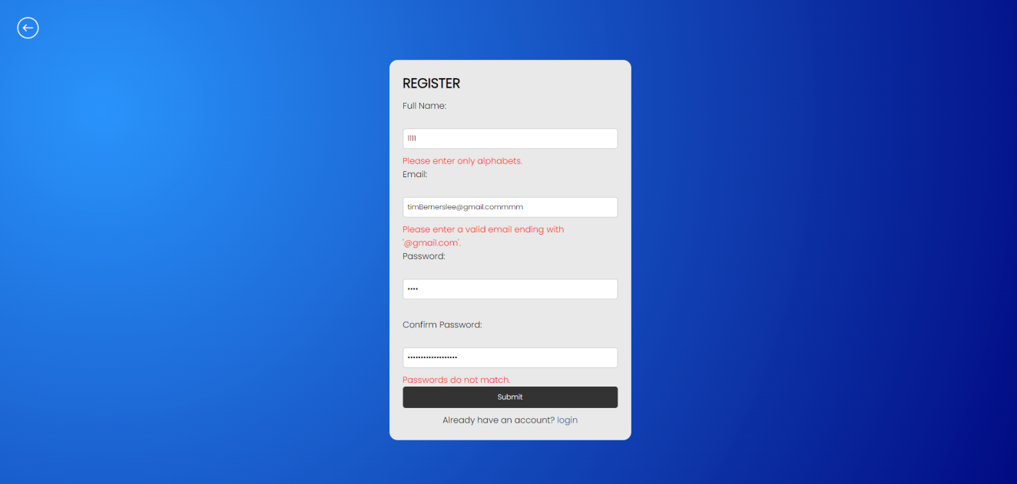

### login-signup-style.css

*{

margin: 0;

padding: 0;

text-decoration: none;

font-family: 'poppins',monospace;

}

body{

height: 100vh;

background-image: radial-gradient( circle farthest-corner at 10% 20%, rgba(37,145,251,0.98) 0.1%, rgba(0,7,128,1) 99.8% );

}

.error {

color: red;

display: none;

}

form {

max-width: 400px;

margin: 0 auto;

}

form h2{

margin-bottom:10px;

font-size: 25px;

}

label {

display: block;

margin-bottom: 5px;

}

input[type="text"],

input[type="email"],

input[type="password"] {

width: 100%;

padding: 8px;

margin-bottom: 10px;

border: 1px solid #ccc;

border-radius: 5px;

box-sizing: border-box;

}

input[type="submit"] {

width: 100%;

padding: 10px;

background-color: #333;

color: #fff;

border: none;

border-radius: 5px;

cursor: pointer;

}

input[type="submit"]:hover {

background-color: #555;

}

.footer p{

align-items: center;

}

form p{

text-align: center;

}

form{

margin-top: 80px;

background-color: #e9e9e9;

border-radius: 15px;

padding: 25px;

}

.home h2{

text-decoration: none;

text-align: center;

}

.footer{

margin-top: 10px;

}

.back{

text-decoration: none;

background-color: #ccc;

padding: 10px 15px;

}

.back a{

background: #E73CE2;

border-radius: 5px;

padding: 5px 10px;

color: #fff;

}

.back a:hover{

background:#3C68E7;

}

### index.html

<html lang="en">

<head>

<meta charset="UTF-8" />

<meta name="viewport" content="width=device-width, initial-scale=1.0" />

<link rel="stylesheet" href="index-style.css">

<title>Home</title>

</head>

<body>

<div class="menu-bar">

<h1 class="logo"><a href="index.html"><img src="logo.png"></a></h1>

<ul>

<li><a href="index.html">Home</a></li>

<li><a href="about.html">About</a></li>

<li><a href="#">Calculator <i class="fas fa-caret-down"></i></a>

<div class="dropdown-menu">

<ul>

<li><a href="../login.php">Simple Calculator</a></li>

<li><a href="../login.php">Factorial Calculator</a></li>

</ul>

</div>

</li>

<li><a href="../login.php">Login</a>

</li>

<li><a href="../signup.php">Signup</a></li>

</div>

<div class="hero"><div class="content">

<h1>SIMPLE CALCULATOR AND A FACTORIAL CALCULATOR</h1>

<p>Click Signup or Login button in the navbar to enter in the calculator mode</p>

</div>

</div>

</body>

</html>



### index2.html

<html lang="en">

<head>

<meta charset="UTF-8" />

<meta name="viewport" content="width=device-width, initial-scale=1.0" />

<link rel="stylesheet" href="index-style.css">

<title>Home</title>

</head>

<body>

<div class="menu-bar">

<h1 class="logo"><a href="index2.html"><img src="logo.png"></a></h1>

<ul>

<li><a href="index2.html">Home</a></li>

<li><a href="about2.html">About</a></li>

<li><a href="#">Calculator <i class="fas fa-caret-down"></i></a>

<div class="dropdown-menu">

<ul>

<li><a href="simple-cal.html">Simple Calculator</a></li>

<li><a href="factorial.html">Factorial Calculator</a></li>

</ul>

</div>

</li>

<li><a href="index.html">Logout</a></li>

</div>

<div class="hero"><div class="content">

<h1>SIMPLE CALCULATOR AND A FACTORIAL CALCULATOR</h1>

<p>Calculation mode is now available on your web</p>

</div>

</div>

</body>

</html>



### index-style.css

:root {

--color-primary: #0073ff;

--color-white: #e9e9e9;

--color-black: #141d28;

--color-black-1: #212b38;

}

* {

margin: 0;

padding: 0;

box-sizing: border-box;

text-decoration: none;

}

body {

font-family: sans-serif;

}

.logo img{

height: 70px;

}

.logo span {

color: var(--color-primary);

}

.menu-bar {

background-image: radial-gradient( circle farthest-corner at 10% 20%, rgba(37,145,251,0.98) 0.1%, rgba(0,7,128,1) 99.8% );

height: 80px;

width: 100%;

display: flex;

justify-content: space-between;

align-items: center;

padding: 0 5%;

position: relative;

box-shadow: 0 0 0 1px #fff;

}

.menu-bar ul {

list-style: none;

display: flex;

}

.menu-bar ul li {

padding: 10px 30px;

position: relative;

}

.menu-bar ul li a {

font-size: 20px;

color: var(--color-white);

text-decoration: none;

transition: all 0.3s;

}

.menu-bar ul li a:hover {

color: var(--color-primary);

}

.fas {

float: right;

margin-left: 10px;

padding-top: 3px;

}

.dropdown-menu {

display: none;

}

.menu-bar ul li:hover .dropdown-menu {

display: block;

position: absolute;

left: 0;

top: 100%;

background-color: var(--color-black);

}

.menu-bar ul li:hover .dropdown-menu ul {

display: block;

margin: 10px;

}

.menu-bar ul li:hover .dropdown-menu ul li {

width: 150px;

padding: 10px;

}

.dropdown-menu-1 {

display: none;

}

.dropdown-menu ul li:hover .dropdown-menu-1 {

display: block;

position: absolute;

left: 150px;

top: 0;

background-color: var(--color-black);

}

.hero {

height: calc(100vh - 80px);

background-image: radial-gradient( circle farthest-corner at 10% 20%, rgba(37,145,251,0.98) 0.1%, rgba(0,7,128,1) 99.8% );

background-position: center;

text-align: center;

align-items: center;

justify-content: center;

padding: 20px;

padding-bottom: 60px;

color: #fff;

}

.content{

margin-top: 250px;

}

.content p{

padding-top: 25px;

font-size: 30px;

text-shadow: 3px 2px 0 rgb(36, 186, 245);

}

.content h1{

font-size: 3rem;

text-shadow: 3px 2px 0 rgb(36, 186, 245);

}

### simple-cal.html

<html lang="en">

<head>

<meta charset="UTF-8" />

<meta name="viewport" content="width=device-width, initial-scale=1.0" />

<link rel="stylesheet" href="style.css" />

<link rel="stylesheet" href="index-style.css">

<title>Simple calculator</title>

<style>

.body{

background-image: radial-gradient( circle farthest-corner at 10% 20%, rgba(37,145,251,0.98) 0.1%, rgba(0,7,128,1) 99.8% );

font-family: 'Poppins', sans-serif;

margin: 0;

padding: 0;

display: flex;

justify-content: center;

align-items: center;

min-height: 100vh;

}

.container {

background-color: #091921;

border-radius: 10px;

box-shadow: -5px -5px 8px rgba(255,255,255,0.1), 5px 5px 15px rgba(0,0,0,0.8);

padding: 50px 20px 60px;

text-align: center;

width: 370px;

}

.container h1 {

color: #22F2AA;

font-size: 28px;

font-weight: 700;

text-transform: uppercase;

}

.container .calculator {

margin-top: 30px;

}

.calculator table {

border-collapse: collapse;

width: 100%;

}

.calculator table td {

padding: 10px;

text-align: center;

}

.calculator input[type="text"] {

width: 100%;

height: 40px;

font-size: 18px;

padding: 5px 10px;

border: none;

border-radius: 5px;

outline: none;

}

.calculator input[type="button"] {

width: 100%;

height: 40px;

font-size: 18px;

border: none;

border-radius: 5px;

background-color: #4CAF50;

color: white;

cursor: pointer;

}

.calculator input[type="button"]:hover {

background-color: #45a049;

}

</style>

</head>

<body>

<div class="menu-bar">

<h1 class="logo"><a href="index2.html"><img src="logo.png"></a></h1>

<ul>

<li><a href="index2.html">Home</a></li>

<li><a href="about2.html">About</a></li>

<li><a href="#">Calculator <i class="fas fa-caret-down"></i></a>

<div class="dropdown-menu">

<ul>

<li><a href="#">Simple Calculator</a></li>

<li><a href="factorial.html">Factorial Calculator</a></li>

</ul>

</div>

</li>

<li><a href="index.html">Logout</a>

</li>

</div>

<div class="body">

<div class="container">

<h1>Calculator</h1>

<div class="calculator">

<form name="calc">

<table border="10">

<tr>

<td colspan="4">

<input type="text" name="display">

</td>

</tr>

<tr>

<td><input type="button" value="0" onclick="calc.display.value+='0'"></td>

<td><input type="button" value="1" onclick="calc.display.value+='1'"></td>

<td><input type="button" value="2" onclick="calc.display.value+='2'"></td>

<td><input type="button" value="+" onclick="calc.display.value+='+'"></td>

</tr>

<tr>

<td><input type="button" value="3" onclick="calc.display.value+='3'"></td>

<td><input type="button" value="4" onclick="calc.display.value+='4'"></td>

<td><input type="button" value="5" onclick="calc.display.value+='5'"></td>

<td><input type="button" value="-" onclick="calc.display.value+='-'"></td>

</tr>

<tr>

<td><input type="button" value="6" onclick="calc.display.value+='6'"></td>

<td><input type="button" value="7" onclick="calc.display.value+='7'"></td>

<td><input type="button" value="8" onclick="calc.display.value+='8'"></td>

<td><input type="button" value="x" onclick="calc.display.value+='*'"></td>

</tr>

<tr>

<td><input type="button" value="9" onclick="calc.display.value+='9'"></td>

<td><input type="button" value="C" onclick="calc.display.value=''"></td>

<td><input type="button" value="=" onclick="calc.display.value=eval(calc.display.value)"></td>

<td><input type="button" value="/" onclick="calc.display.value+='/'"></td>

</tr>

</table>

</form>

</div>

</div>

</div>

</body>

</html>

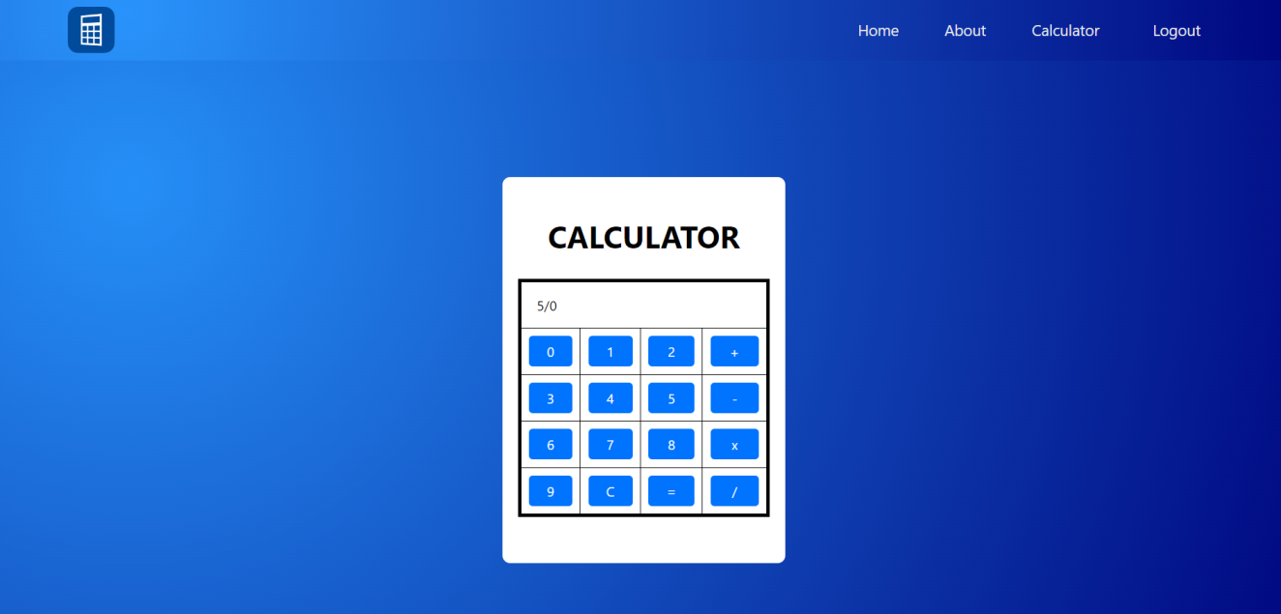

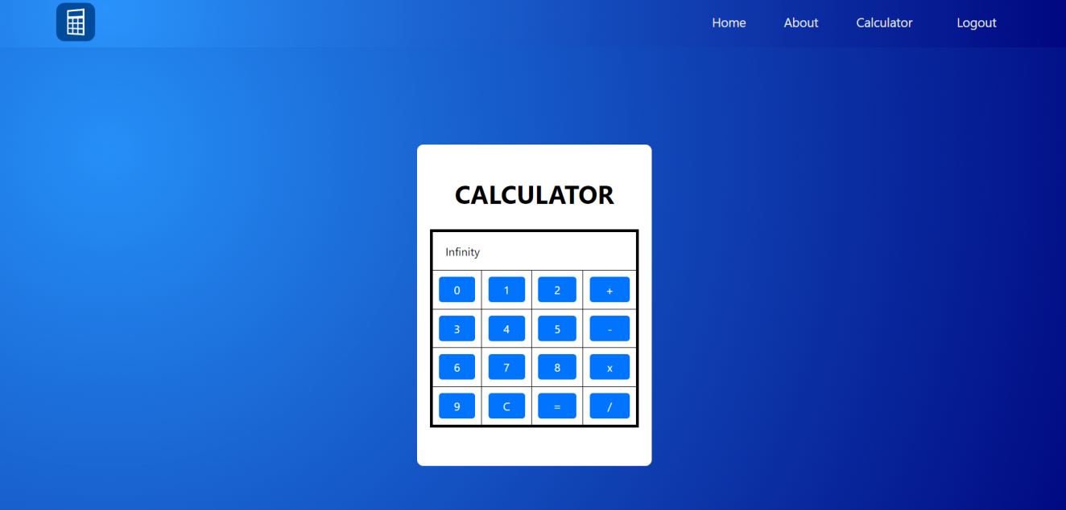

### factorial.html

<html lang="en">

<head>

<meta charset="UTF-8" />

<meta name="viewport" content="width=device-width, initial-scale=1.0" />

<link rel="stylesheet" href="style.css" />

<link rel="stylesheet" href="index-style.css">

<title>Factorial</title>

<style>

.container {

width: 400px;

margin-top: 20vh;

padding: 20px;

border: 1px solid #ccc;

border-radius: 5px;

box-shadow: 0 0 10px rgba(0, 0, 0, 0.1);

}

input[type="number"] {

width: 100%;

padding: 10px;

margin-bottom: 10px;

border: 1px solid #ccc;

border-radius: 5px;

box-sizing: border-box;

}

button {

width: 100%;

padding: 10px;

background-color: #007bff;

color: #fff;

border: none;

border-radius: 5px;

cursor: pointer;

}

button:hover {

background-color: #0056b3;

}

p {

margin-top: 10px;

font-weight: bold;

}

h2 {

color: white;

}

body {

background-image: radial-gradient( circle farthest-corner at 10% 20%, rgba(37,145,251,0.98) 0.1%, rgba(0,7,128,1) 99.8% );

display: flex;

flex-direction: column;

align-items: center;

justify-content: flex-start;

min-height: 100vh;

}

</style>

</head>

<body>

<div class="menu-bar">

<h1 class="logo"><a href="index2.html"><img src="logo.png"></a></h1>

<ul>

<li><a href="index2.html">Home</a></li>

<li><a href="about2.html">About</a></li>

<li><a href="#">Calculator <i class="fas fa-caret-down"></i></a>

<div class="dropdown-menu">

<ul>

<li><a href="simple-cal.html">Simple Calculator</a></li>

<li><a href="#">Factorial Calculator</a></li>

</ul>

</div>

</li>

<li><a href="index.html">Logout</a></li>

</div>

<div class="container">

<h2>Factorial Calculator</h2>

<input type="number" id="number" placeholder="Enter a number">

<button onclick="calculateFactorial()">Calculate Factorial</button>

<p id="result"></p>

</div>

<script>

function calculateFactorial() {

var numberInput = document.getElementById("number").value;

var number = parseInt(numberInput);

if (isNaN(number)) {

alert("Please enter a valid number.");

return;

}

var factorial = 1;

for (var i = 1; i <= number; i++) {

factorial *= i;

}

document.getElementById("result").innerHTML = "Factorial of " + number + " is " + factorial;

}

</script>

</body>

</html>

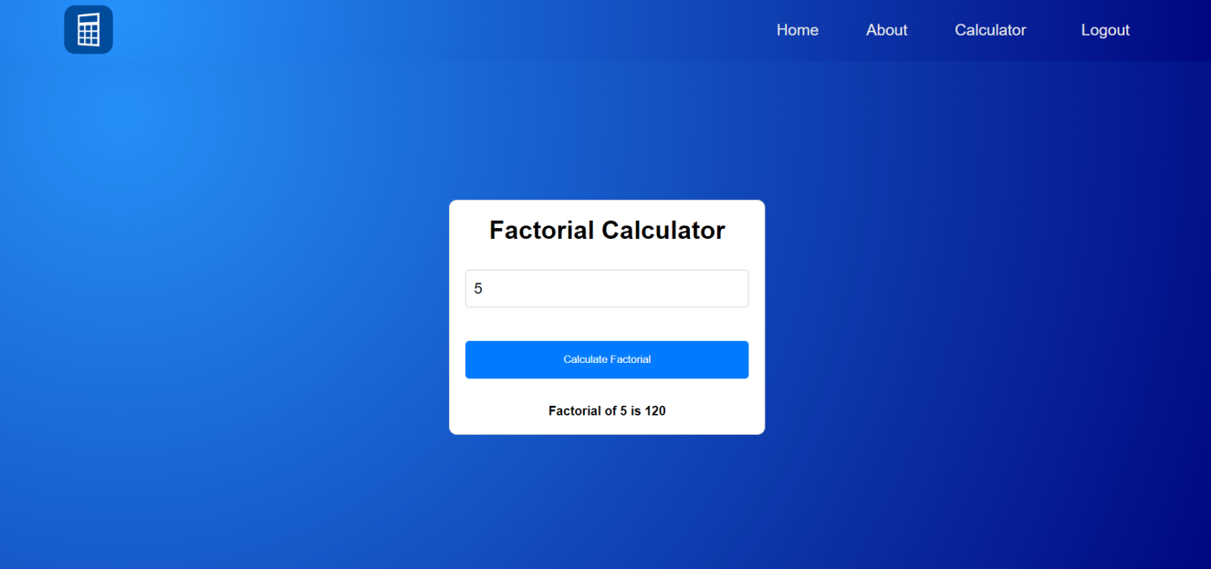

### about.html

<html lang="en">

<head>

<meta charset="UTF-8" />

<meta name="viewport" content="width=device-width, initial-scale=1.0" />

<link rel="stylesheet" href="style.css" />

<title>About</title>

<link rel="stylesheet" href="about-style.css">

</head>

<body>

<div class="menu-bar">

<h1 class="logo"><a href="index.html"><img src="logo.png"></a></h1>

<ul>

<li><a href="index.html">Home</a></li>

<li><a href="about.html">About</a></li>

<li><a href="#">Calculator <i class="fas fa-caret-down"></i></a>

<div class="dropdown-menu">

<ul>

<li><a href="../login.php">Simple Calculator</a></li>

<li><a href="../login.php">Factorial Calculator</a></li>

</ul>

</div>

</li>

<li><a href="../login.php">Login</a>

</li>

<li><a href="../signup.php">Signup</a></li>

</div>

<div class="hero">

<section class="team">

<br><br>

<h1>Meet Our Team</h1>

<div class="team-cards">

<div class="card">

<div class="card-img">

<img src="Team-Photos/ravi.jpg" alt="Team 1">

</div>

<div class="card-info">

<p class="card-role">Ravi Mandal</p>

<p class="card-email">ravi0mandal@gmail.com</p>

<p><button class="button">9828863031</button></p>

</div>

</div>

<div class="card">

<div class="card-img">

<img src="Team-Photos/rojal.jpg" alt="Team 2">

</div>

<div class="card-info">

<p class="card-role">Rojal Bikram Thapa</p>

<p class="card-email">rojalbikram55.com</p>

<p><button class="button">9822565523</button></p>

</div>

</div>

<div class="card">

<div class="card-img">

<img src="Team-Photos/santosh.jpg" alt="Team 3">

</div>

<div class="card-info">

<p class="card-role">Santosh Budhathoki</p>

<p class="card-email">budhathokisantosh792@gmail.com</p>

<p><button class="button">9855256532</button></p>

</div>

</div>

<div class="card">

<div class="card-img">

<img src="Team-Photos/all.jpeg" alt="Team 4">

</div>

<div class="card-info">

<p class="card-role">Rishikesh Dhakal</p>

<p class="card-email">rishikeshdhakal55@gmail.com</p>

<p><button class="button">9755865420/button></p>

</div>

</div>

<div class="card">

<div class="card-img">

<img src="Team-Photos/shekhar.jpg" alt="Team 5">

</div>

<div class="card-info">

<p class="card-role">Shekhar Shrestha</p>

<p class="card-email">shekharshrestha88@gmail.com</p>

<p><button class="button">9888545120</button></p>

</div>

</div>

<div class="card">

<div class="card-img">

<img src="Team-Photos/all.jpeg" alt="Team 6">

</div>

<div class="card-info">

<p class="card-role">Ritesh Bhandari</p>

<p class="card-email">riteshbhandari33@gmail.com</p>

<p><button class="button">9755231044</button></p>

</div>

</div>

<div class="card">

<div class="card-img">

<img src="Team-Photos/all.jpeg" alt="Team 7">

</div>

<div class="card-info">

<p class="card-role">Sakshem Neupane</p>

<p class="card-email">sakshem222@gmail.com</p>

<p><button class="button">9828445620</button></p>

</div>

</div>

<div class="card">

<div class="card-img">

<img src="Team-Photos/all.jpeg" alt="Team 8">

</div>

<div class="card-info">

<p class="card-role">Bibek Basnet</p>

<p class="card-email">bibekbasnet66@gmail.com</p>

<p><button class="button">9828864444</button></p>

</div>

</div>

<div class="card">

<div class="card-img">

<img src="Team-Photos/aashan.jpg" alt="Team 9">

</div>

<div class="card-info">

<p class="card-role">Aasan Khanal</p>

<p class="card-email">aasankhanal66@gmail.com</p>

<p><button class="button">9828445560</button></p>

</div>

</div>

</div>

</section>

</div>

</div>

</body>

</html>

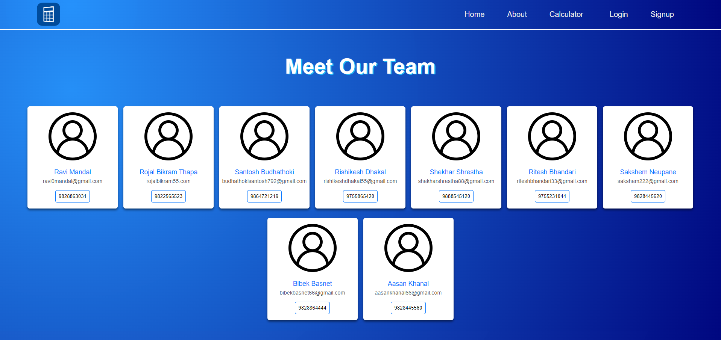

### about2.html

<html lang="en">

<head>

<meta charset="UTF-8" />

<meta name="viewport" content="width=device-width, initial-scale=1.0" />

<link rel="stylesheet" href="style.css" />

<title>About</title>

<link rel="stylesheet" href="about-style.css">

</head>

<body>

<div class="menu-bar">

<h1 class="logo"><a href="index2.html"><img src="logo.png"></a></h1>

<ul>

<li><a href="index2.html">Home</a></li>

<li><a href="about2.html">About</a></li>

<li><a href="#">Calculator <i class="fas fa-caret-down"></i></a>

<div class="dropdown-menu">

<ul>

<li><a href="simple-cal.html">Simple Calculator</a></li>

<li><a href="factorial.html">Factorial Calculator</a></li>

</ul>

</div>

</li>

<li><a href="index.html">Logout</a>

</li>

</div>

<div class="hero">

<section class="team">

<br><br>

<h1>Meet Our Team</h1>

<div class="team-cards">

<div class="card">

<div class="card-img">

<img src="Team-Photos/ravi.jpg" alt="Team 1">

</div>

<div class="card-info">

<p class="card-role">Ravi Mandal</p>

<p class="card-email">ravi0mandal@gmail.com</p>

<p><button class="button">9828863031</button></p>

</div>

</div>

<div class="card">

<div class="card-img">

<img src="Team-Photos/rojal.jpg" alt="Team 2">

</div>

<div class="card-info">

<p class="card-role">Rojal Bikram Thapa</p>

<p class="card-email">rojalbikram55.com</p>

<p><button class="button">9822565523</button></p>

</div>

</div>

<div class="card">

<div class="card-img">

<img src="Team-Photos/santosh.jpg" alt="Team 3">

</div>

<div class="card-info">

<p class="card-role">Santosh Budhathoki</p>

<p class="card-email">budhathokisantosh792@gmail.com </p>

<p><button class="button">9864721219</button></p>

</div>

</div>

<div class="card">

<div class="card-img">

<img src="Team-Photos/all.jpeg" alt="Team 4">

</div>

<div class="card-info">

<p class="card-role">Rishikesh Dhakal</p>

<p class="card-email">rishikeshdhakal55@gmail.com</p>

<p><button class="button">9755865420/button></p>

</div>

</div>

<div class="card">

<div class="card-img">

<img src="Team-Photos/shekhar.jpg" alt="Team 5">

</div>

<div class="card-info">

<p class="card-role">Shekhar Shrestha</p>

<p class="card-email">shekharshrestha88@gmail.com</p>

<p><button class="button">9888545120</button></p>

</div>

</div>

<div class="card">

<div class="card-img">

<img src="Team-Photos/all.jpeg" alt="Team 6">

</div>

<div class="card-info">

<p class="card-role">Ritesh Bhandari</p>

<p class="card-email">riteshbhandari33@gmail.com</p>

<p><button class="button">9755231044</button></p>

</div>

</div>

<div class="card">

<div class="card-img">

<img src="Team-Photos/all.jpeg" alt="Team 7">

</div>

<div class="card-info">

<p class="card-role">Sakshem Neupane</p>

<p class="card-email">sakshem222@gmail.com</p>

<p><button class="button">9828445620</button></p>

</div>

</div>

<div class="card">

<div class="card-img">

<img src="Team-Photos/all.jpeg" alt="Team 8">

</div>

<div class="card-info">

<p class="card-role">Bibek Basnet</p>

<p class="card-email">bibekbasnet66@gmail.com</p>

<p><button class="button">9828864444</button></p>

</div>

</div>

<div class="card">

<div class="card-img">

<img src="Team-Photos/aashan.jpg" alt="Team 9">

</div>

<div class="card-info">

<p class="card-role">Aasan Khanal</p>

<p class="card-email">aasankhanal66@gmail.com</p>

<p><button class="button">9828445560</button></p>

</div>

</div>

</div>

</section>

</div>

</div>

</body>

</html>

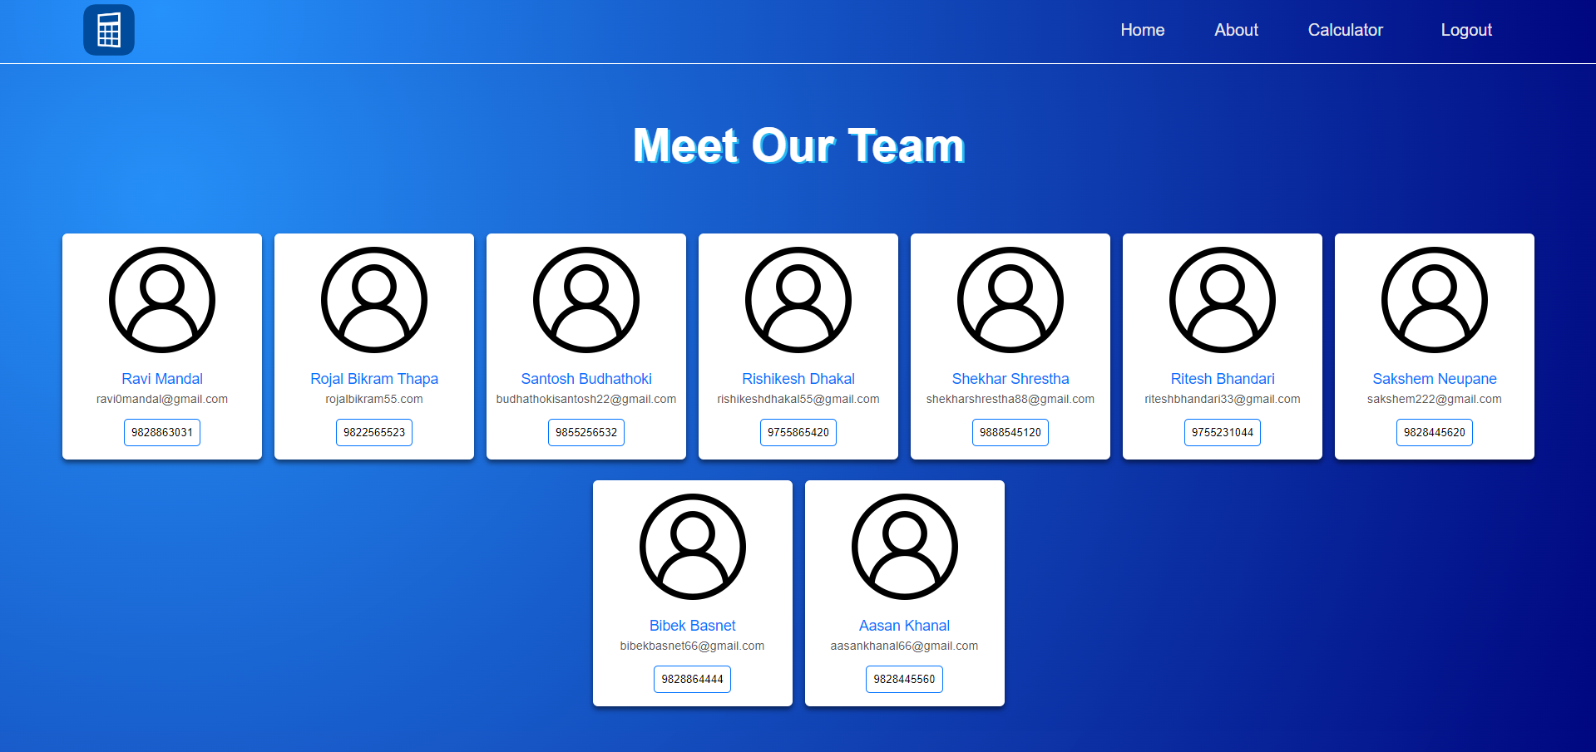

### about-style.css

:root {

--color-primary: #0073ff;

--color-white: #e9e9e9;

--color-black: #141d28;

--color-black-1: #212b38;

}

* {

margin: 0;

padding: 0;

box-sizing: border-box;

text-decoration: none;

}

body {

font-family: sans-serif;

}

.logo img{

height: 70px;

}

.menu-bar {

background-image: radial-gradient( circle farthest-corner at 10% 20%, rgba(37,145,251,0.98) 0.1%, rgba(0,7,128,1) 99.8% );

height: 80px;

height: 80px;

width: 100%;

display: flex;

justify-content: space-between;

align-items: center;

padding: 0 5%;

position: relative;

}

.menu-bar ul {

list-style: none;

display: flex;

}

.menu-bar ul li {

padding: 10px 30px;

position: relative;

}

.menu-bar ul li a {

font-size: 20px;

color: var(--color-white);

text-decoration: none;

transition: all 0.3s;

}

.menu-bar ul li a:hover {

color: var(--color-primary);

}

.fas {

float: right;

margin-left: 10px;

padding-top: 3px;

}

.dropdown-menu {

display: none;

}

.menu-bar ul li:hover .dropdown-menu {

display: block;

position: absolute;

left: 0;

top: 100%;

background-color: var(--color-black);

}

.menu-bar ul li:hover .dropdown-menu ul {

display: block;

margin: 10px;

}

.menu-bar ul li:hover .dropdown-menu ul li {

width: 150px;

padding: 10px;

}

.dropdown-menu-1 {

display: none;

}

.dropdown-menu ul li:hover .dropdown-menu-1 {

display: block;

position: absolute;

left: 150px;

top: 0;

background-color: var(--color-black);

}

.hero {

max-height: calc(100vh - 80px);

background: #212b38;

background-position: center;

color: #fff;

align-items: center;

}

* {

margin: 0;

padding: 0;

box-sizing: border-box;

}

body {

font-family: Arial, sans-serif;

}

header {

background-color: white;

color: rgb(0, 0, 0);

padding: 10px 0;

position: fixed;

width: 100%;

z-index: 100;

box-shadow: 0 2px 2px rgba(0, 0, 0, 0.2);

}

nav {

display: flex;

justify-content: space-between;

align-items: center;

margin: 5px auto;

padding: 0 20px;

}

.logo {

font-size: 1.5rem;

font-weight: bold;

color: #40b736;

}

.nav-links {

list-style: none;

display: flex;

}

.nav-links li {

margin-right: 20px;

}

.nav-links a {

color: rgb(0, 0, 0);

padding: 10px;

font-weight: bold;

text-decoration: none;

}

.nav-links a:hover {

background-color: #40b736;

border-radius: 4px;

color: white;

}

.team {

padding: 30px 0;

text-align: center;

background-image: radial-gradient( circle farthest-corner at 10% 20%, rgba(37,145,251,0.98) 0.1%, rgba(0,7,128,1) 99.8% );

}

.team h1 {

font-size: 2.5rem;

margin-bottom: 20px;

}

.team-cards {

display: flex;

flex-wrap: wrap;

justify-content: center;

gap: 15px;

margin-top: 20px;

}

.card {

background-color: white;

border-radius: 6px;

box-shadow: 0 4px 6px rgba(0, 0, 0, 0.5);

overflow: hidden;

transition: transform 0.2s, box-shadow 0.2s;

width: 18rem;

height: 25rem;

margin-top: 10px;

}

.card:hover {

transform: translateY(-5px);

box-shadow: 0 8px 12px rgba(0, 0, 0, 0.5);

}

.card-img {

width: 18rem;

height: 12rem;

}

.card-img img {

width: 100%;

height: 100%;

object-fit: fill;

}

.card-info button {

margin: 2rem 1rem;

}

.card-name {

font-size: 2rem;

margin: 10px 0;

}

.card-role {

font-size: 1rem;

color: #888;

margin: 5px 0;

}

.card-email {

font-size: 1rem;

color: #555;

}

section{

background:#212b38;

}

@media (max-width: 768px) {

nav {

display: block;

}

.logo {

text-align: center;

}

.nav-links {

margin-top: 1rem;

justify-content: space-between;

}

.nav-links li {

margin-right: 0;

}

.about h1 {

font-size: 2rem;

}

.about p {

font-size: 0.9rem;

}

.about-info {

flex-direction: column;

text-align: center;

}

.about-img {

width: 60%;

height: 60%;

margin-bottom: 1rem;

}

.about-info p {

margin: 1rem 2rem;

}

.about-info button {

margin: 1rem 2rem;

width: 10rem;

}

.team {

margin: 0 1rem;

}

}

# OUTPUT

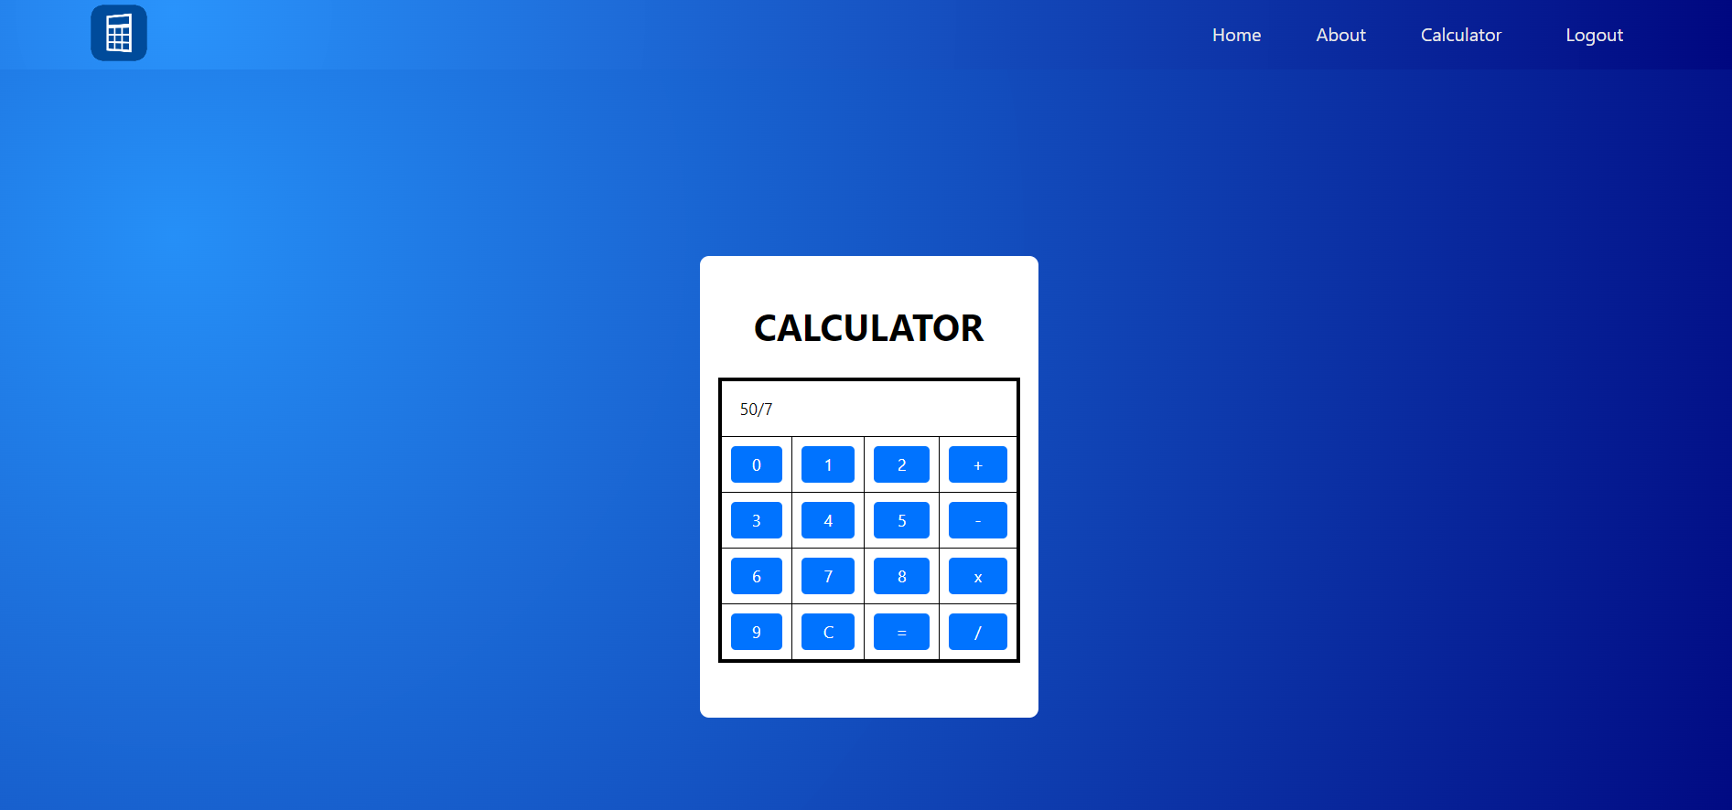

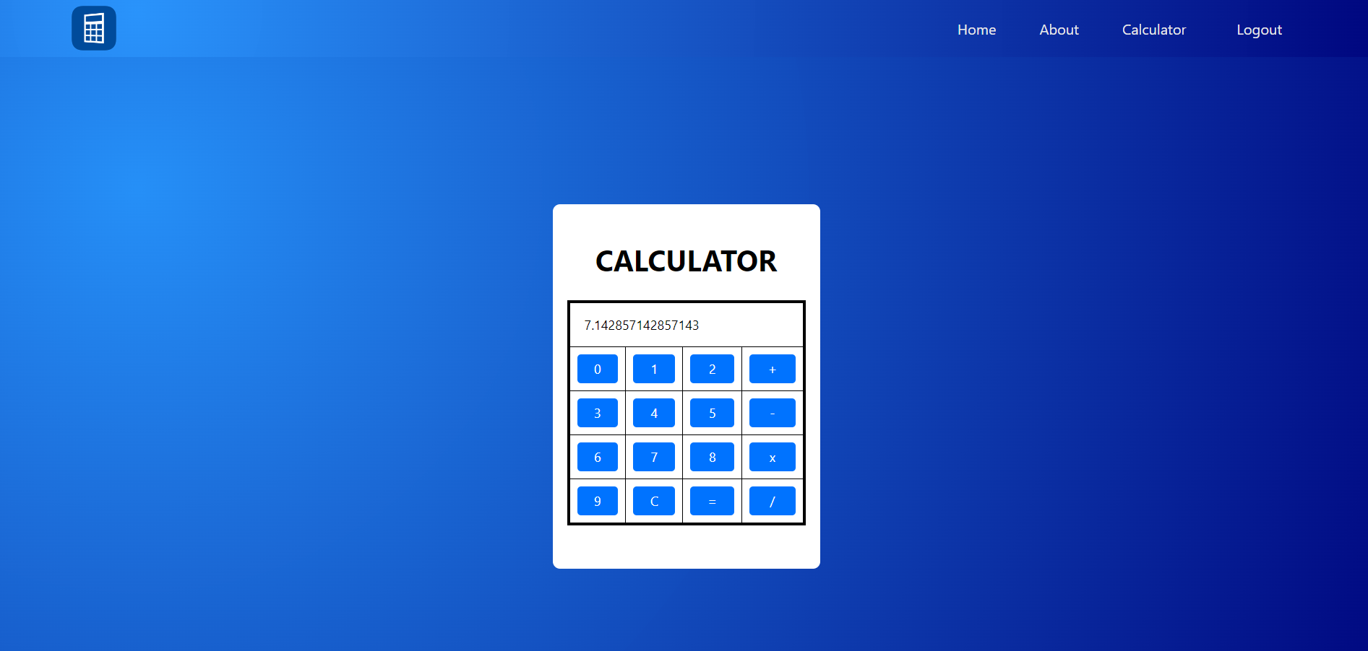

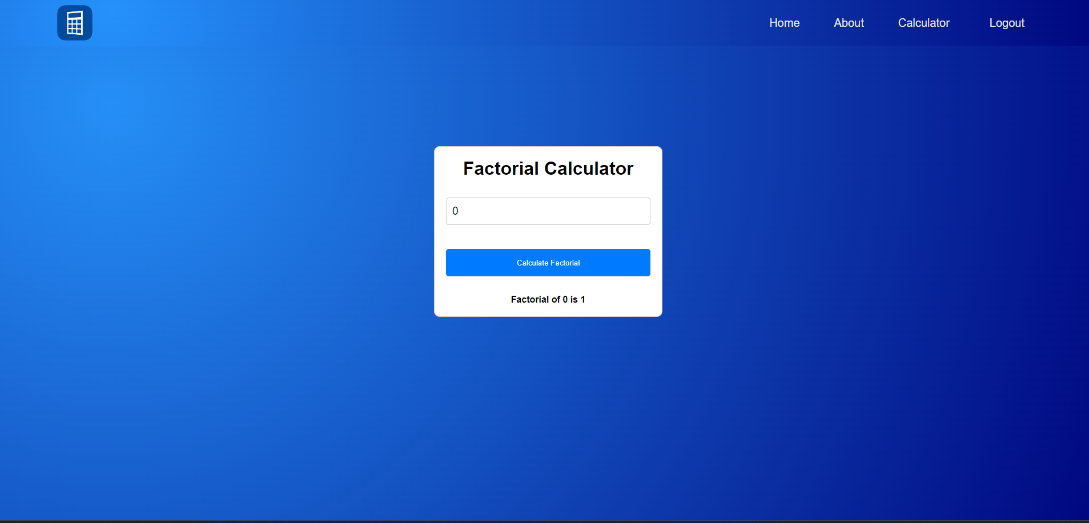

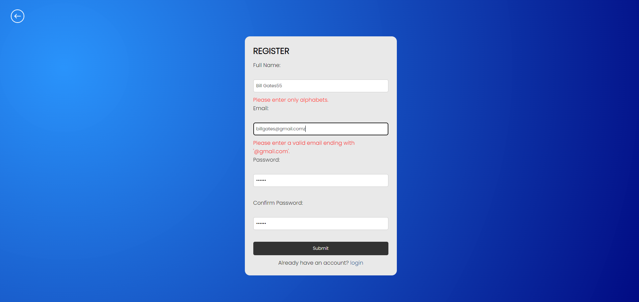

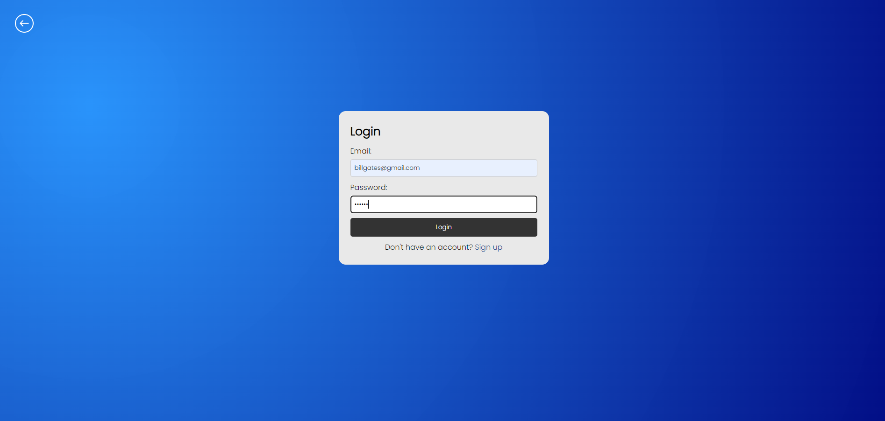

# FINDING

The calculator and factorial functionalities perform as expected, accurately computing mathematical operations.

The login/signup system enhances user engagement and data security.

User feedback indicates ease of use and satisfaction with the website's features.

Minimal errors or bugs were encountered during testing, demonstrating robust functionality.

Future iterations could focus on additional features or optimization for improved user experience.

# FUTURE SCOPE AND FUTURE ENHANCEMENT

The future scope for the web-based calculator project includes incorporating additional functionalities to enhance user experience, such as a history feature to track previous calculations, support for advanced mathematical operations, and the ability to customize themes for personalization. Furthermore, integrating real-time currency conversion, unit conversion, and basic graphing capabilities can broaden the calculator's utility. Implementing responsive design to ensure seamless usage across various devices and browsers would enhance accessibility. Additionally, introducing user authentication and saving capabilities could enable users to store their preferred settings and calculations securely. Integration with external APIs for accessing live data, such as stock prices or weather forecasts, could provide users with valuable information directly within the calculator interface. Finally, exploring opportunities for collaboration and sharing functionalities, allowing users to share calculations or collaborate on projects in real-time, could expand the calculator's usefulness in educational and professional settings.

# CONCLUSION

From the above project, it is evident that a website offering calculator and factorial functionalities, coupled with a secure login and signup system, provides users with convenient and efficient tools for mathematical computations. With intuitive design and robust security measures, the platform enhances user experience while ensuring data integrity and privacy. In conclusion, this project successfully demonstrates the fusion of practical utility with modern web technology to meet the needs of users seeking reliable mathematical tools online.

# REFERENCES

1. CSS Gradient (2017). CSS Gradient — Generator, Maker, and Background. [online] CSS Gradient. Available at: https://cssgradient.io/.

‌

1. W3Schools (n.d.). W3Schools Online Web Tutorials. [online] W3schools.com. Available at: https://www.w3schools.com/.

‌

1. javatpoint (2011). Tutorials - Javatpoint. [online] www.javatpoint.com. Available at: https://www.javatpoint.com/.

‌

1. Tutorials Point (2019). JavaScript - Form Validation - Tutorialspoint. [online] Tutorialspoint.com. Available at: https://www.tutorialspoint.com/javascript/javascript_form_validations.htm.

‌

1. www.atulnag.in. (n.d.). Atul Nag - Web Technology. [online] Available at: https://www.atulnag.in/courses/webtechnology

‌

1. OpenAI (2024). ChatGPT. [online] chat.openai.com. Available at: https://chat.openai.com.

‌

1. www.codewithharry.com. (n.d.). Learn to code online - CodeWithHarry. [online] Available at: https://www.codewithharry.com/.

‌

1. Heritage Publishers & Distributors Pvt. Ltd. (n.d.). Buy books online in Nepal - Heritage Publishers & Distributors. [online] Available at: https://heritagebooks.com.np

‌